Team Members

Ankit karki

sudip gimire

sudip parajuli

sabin paudel

bishal paudel

Initial Project Plan

V.R.B Real estate and consultant

# Revision

|  |  |  |  |
| --- | --- | --- | --- |
| Version Number | Date approved | Approved by | Description |
| 1.0 | 2016-01-01 | Abbas Shaik | Project handbook |

# Preface

This project is about developing website and android app for V.R.Buildtec where this document contain all the related document that is needed for this project. This is our first document which contain document up to pat four where it has cover the process model, plan , dividing task and what method and technique we are using. The technique we are using is SCRUM method. This methodology includes the sprints in which evolution of the project is done on scheduled dates to makes project dates. The audience for the project are the people who wants to own and lease the property.

Table of Contents

Revision 1

Preface 1

List of Figures 2

List of Tables 2

Vision Statement 4

1. Introduction 4

1.1 Project Overview 4

1.2 Project Deliverables 5

1.3 Evolution of the Handbook 5

1.4 Reference Materials 5

1.5 Definitions and Acronyms 5

2. Organization 6

2.1 Process Model 6

2.2 Organizational Structure 7

2.3 Organization Boundaries and Interfaces 8

2.4 Project Responsibilities 8

3. Managerial Process 9

3.1 Management Objectives and Priorities 9

3.2 Assumptions, Dependencies, and Constraints 9

4. Technical Process 10

4.1 Methods, Tools, and Techniques 10

4.2 Software Documentation 11

5. High level Project Plan 12

# List of Figures

1

# List of Tables

6

# Vision Statement

|  |  |
| --- | --- |
| Project Start Date | 20/07/2020 |
| Project finish date | 10/08/2020 |
| Project type | Document |
| Project Manager | Ankit Karki |
| Estimated Budget | $10000 |

Overview

We are developing android app and web app for this real estate company according to the requirement of our client. The aims of the project is to develop a portal for registered & existing customers to login, raise issues of concern and also monitor the reports of the daily work. The website also will list all the services undertaken by the company and used as a marketing tool for a prospective client. Through the website it would contain end to end process document as per customer perspective. Our project is to provide every function that our client needs. This website and app will provide every details of the property required for the customer.

# Introduction

## 1.1 Project Overview

As we are the one of the leading app and website developer with experience of 5 year we are always with our client. The objective of this project is to aims to develop a portal for registered & existing customers to login, raise issues of concern and also monitor the reports of the daily work. The objectives is to develop the website which will contain all the services undertaken by the company and used as a marketing tool for a prospective client. Our goal is to fulfil the client requirement as per where they can access every equipment that can be use in there field. The other goal are website development, documentation of the files, client login as their will be reward for the old customer.

This project include the website which contain brief description of the website, different cleaning product, contact detail where their will be client and staff login to make the website user friendly. The other aim is to design end-to-end process document from the customer perspective. We will also look forward to Implement a notification mechanism that sends email alerts and SMS notifications to broker, customer and manager. There will be Calculation of the time taken to complete each ad-hoc issue raised by the customer for reporting purpose.

## 1.2 Project Deliverables

|  |  |  |  |
| --- | --- | --- | --- |
| No | TASK | DUE DATE | RESPONSIBILITIES |
| 1 | User manual | 22 Aug | Ankit |
| 2 | Installation manual | 22 Aug | Sudip |
| 3 | Technical documentation | 24 Aug | Sabin |
| 4 | Project overview | 25 Aug | Karki |
| 5 | Project backlog | 25 Aug | Sudip |
| 6 | Project handbook | 27 Aug | Sudip G. |
| 7 | Meeting | 29 Aug | bishal |
| 8 | Sprint documentation | 1 Sep | Ghimire |
| 9 | Design documentation | 2 Sep | Parajuli |
| 10 | Presentation | 5 Sep | Sabin |

## 1.3 Evolution of the Handbook

As the project will continue when there is any kind of problem the team member will contact the project manager so he will send the notice to every team member will be making change according the problem to solve it as we will conduct online meting in the WhatsApp group. After finding out the problem the project manager will change in the handbook in form of sprints. These changes are schedule after the completion of every sprint. As the project manager update the handbook he will send message to every group member about it as group member will response to it. As every group of five member will be working together as the request of the project manager. Every change is responsible to the project manager.

## 1.4 Reference Materials

<http://www.ieee.org/documents/ieeecitationref.pdf>

<http://www.apastyle.org/>

<https://www.denysys.com/blog/5-benefits-of-agile-methodology/>

https://blog.prototypr.io/software-documentation-types-and-best-practices-1726ca595c7f

## 1.5 Definitions and Acronyms

Define, or provide references to the definition of, terms, acronyms, or abbreviations used in the handbook.

|  |  |
| --- | --- |
| Term | Definition |
| Appointment | A request made by customer to meet the client. |
| Login | A section where user can access to his task. |
| Bills | A formal document of payment owned by client. |
| Alert and notification | A section where client will receive in the update of their task |
| Registration | A place where someone can make their profile |
| Design | A section where admin can access what changes can be done for website. |

# Organization

## 2.1 Process Model

Agile methodology is a procedure by which a group can deal with an undertaking by separating it into a several phases and including consistent joint effort with partners and constant improvement and emphasis at each stage. The Agile approach starts with customers depicting how the final result will be utilized and what issue it will unravel. This explains the client's desires to the undertaking group. When the work starts, groups cycle through a procedure of arranging, executing, and assessing — which may very well change the last deliverable to meet the client's requirements better. Continuous collaboration is key, both among team members and with project stakeholders, to make fully-informed decisions.

As this project has been separated into different five sprints and will be covering different user stories in our project.AS the sprint is completed the useful one will be use as a part of the project.

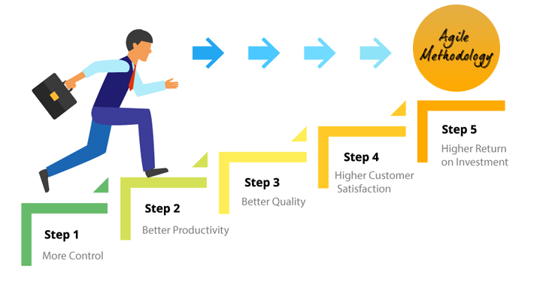

<https://www.denysys.com/blog/5-benefits-of-agile-methodology/>

Each sprint has time to finish so project will be completed in the time:

|  |  |
| --- | --- |
| Sprints | Estimated time |
| Iterative 1 (Main page) | 22-07-2020 |
| Iterative 2 (Notification) | 24-07-2020 |
| Iterative 3 (Payment) | 26-07-2020 |
| Iterative 4 (Administration) | 02-08-2020 |
| Iterative 5 (Dashboard) | 05-08-2020 |

Team

member

Sudip G.

Team

member

Sudip P

Product owner

Team

member

Bishal

Team member

Sabin

Project leader

Ankit

## 2.2 Organizational Structure

The project will be divided so that all team member has equal responsibilities toward the project. The task will be divided by project leader and assigned to every group member according to their skill. Project manager will look after how team member are going with their task and will be conducting online meeting to be inform about the task as is there is any problem or we can make update on the project before moving future so later their will be no problem. Every changes done by team member would be inform to the project manager so that later after there project is approve their will be no change inn the project.

## 2.3 Organization Boundaries and Interfaces

As it is important to have good relation with the client or stakeholder where our team member will be always be doing their work within their boundaries where they will not go against the boundaries will would have bad impact to the project which isn’t accept by us. So it is responsible to our client that they should be up to date with the client requirement. Project manager will be conducting meeting with the client as well as team member whether the project is running in the right track or not. It is the important part that the client requirement is fulfilled as this project is mostly for our client so every arear should be listed or done carefully as per the client satisfaction.

## 2.4 Project Responsibilities

|  |  |  |  |
| --- | --- | --- | --- |
| Role | Name | Responsibilities | Email |
| Owner | SASBS | Providing every kind of document that are need to be done. |  |
| Project leader | Ankit Karki | Managing the team. Dividing task to the every team member according to their skills. Look after every requirement of the project and lead the team member towards the goals. |  |
| System analyst | Sabin Paudel | Analysing the requirement for the system consulting with clients and other related person. |  |
| Test Analyst | Sudip Parajuli | Testing there data conducted in the test cycle suggesting if wrong what improvement can be done as well as collecting feedback. |  |
| Programmer | Sudip Ghimire | Coding specialist, writing the code for the application software and looking after every program that is created. |  |
| Documentation | Bishal Paudel | Documenting the project required document that are run in the project. |  |

# Managerial Process

## 3.1 Management Objectives and Priorities

This Project aims to develop a portal for registered & existing customers to login, raise issues of concern and also monitor the reports of the daily work. The website also should list all the services undertaken by the company and used as a marketing tool for a prospective client. For the completion of the project it requires deep knowledge about the various types of tool and software that are going to be used in the project and how the team member is going to use the tools to fulfil the requirement .As there can be occurrence of conflict will impact the project where every team will be aware of that and they will be consider handling there thought that are affecting to the other team member as they have some issue will other team member they will first go with project manager and will be resolve that problem so project will run smoothly as finish in the require time.

## 3.2 Assumptions, Dependencies, and Constraints

Assumption

An assumption is what you believe to be true. These are anticipated events or circumstances that are expected during project’s life cycle. Assumptions may not end up being true. Sometimes, they can be false and it may affect your project. This adds risk to the project. As here are the some assumption:

* As all team member will give up to date about the project to the project manager so that later there wouldn’t be any kind of the problem in the project.
* Every team member should look what are the client requirement and how can we meet the goal of the client with using their techniques to make the project user friendly.
* The data of the client will be restore in the computer.
* After the completion of project the client can log into the webpage using their ID.

Constraints  
There will be consideration of time ,cost and so on the project;

* The project will be finish in the estimated time .
* The project will be quality as per the requirement needed.
* Every one will be look after the requirement time as per the material requirement.
* There will be no problem in the salary of the employee.
* The project should have minimum financial aid requirement.
* Every equipment will be supply according to save the time to maintain the time allocate.

Dependencies

* It is compulsory that employee are trained properly so that they shouldn’t depend on other.
* There should be proper supply of hardware equipment to run the project properly.
* If some problem occur they need to contact there project manager.

# Technical Process

## Methods, Tools, and Techniques

Scrum is an agile way to manage a project, usually software development. Agile software development with Scrum is often perceived as a methodology; but rather than viewing Scrum as methodology, think of it as a framework for managing a process. In the agile Scrum world, instead of providing complete, detailed descriptions of how everything is to be done on a project, much of it is left up to the Scrum software development team. This is because the team will know best how to solve the problem they are presented.

https://www.mountaingoatsoftware.com/agile/scrum

For this one we use :

1-Product backlog

-A Product Backlog is rarely finished. Its most punctual improvement spreads out the at first known and best-got prerequisites. The Product Backlog advances as the item and the earth in which it will be utilized develops. The Product Backlog is dynamic; it continually changes to distinguish what the item should be proper, serious, and helpful. In the event that an item exists, its Product Backlog additionally exists. This is a continuous procedure where the project owner and the Development Team work together on the subtleties of Product Backlog things. During Product Backlog refinement, things are checked on and modified.

2-Sprint Backlog

-The sprint backlog is a list of tasks identified by the Scrum team to be completed during the Scrum sprint. During the sprint planning meeting, the team selects some number of product backlog items, usually in the form of user stories, and identifies the tasks necessary to complete each user story. Most teams also estimate how many hours each task will take someone on the team to complete.

Tools and Techniques

|  |  |
| --- | --- |
| Tools Techniques | Description |
| CSS3 | CSS3 is a language that describes the style of an HTML document.  CSS3 describes how HTML elements should be displayed. |
| HTML | HTML refers to links that connect web pages to one another, either within a single website or between websites. Links are a fundamental aspect of the Web. By uploading content to the Internet and linking it to pages created by other people, you become an active participant in the World Wide Web. |
| Google Doc | Google doc is the platform where we can save our document in a form of cloud. |
| MySQL | It is related to create table on DBMS with the help of entities. |
| Lucid chart | Lucid chart is the online platform where we can draw different type of prototype diagram. |

## Software Documentation

**System documentation** represents documents that describe the system itself and its parts. It includes requirements documents, design decisions, architecture descriptions, program source code, and help guides.

**User documentation** covers manuals that are mainly prepared for end-users of the product and system administrators. User documentation includes tutorials, user guides, troubleshooting manuals, installation, and reference manuals.

**Process documentation** represents all documents produced during development and maintenance that describe… well, process. The common examples of process documentation are project plans, test schedules, reports, standards, meeting notes, or even business correspondence.

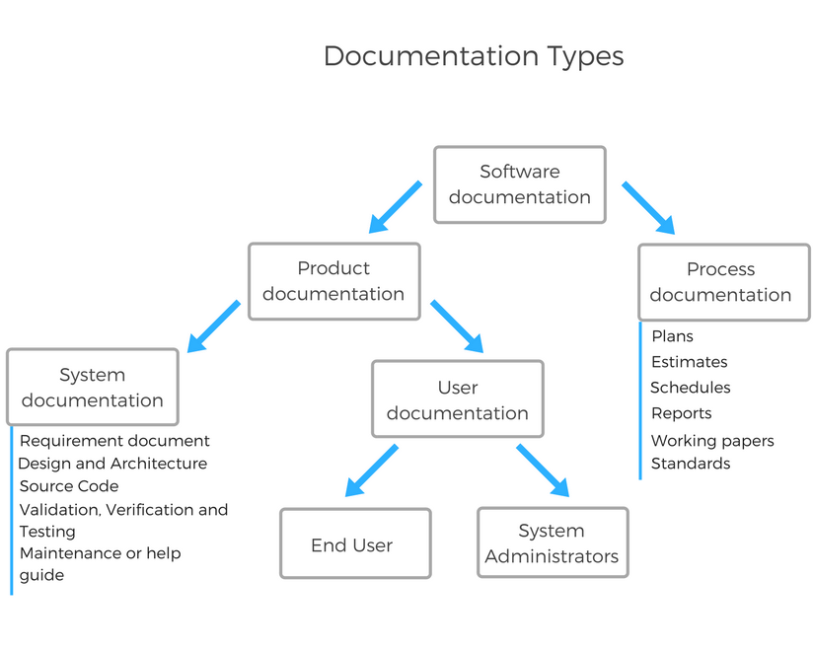

# 5. High level Project Plan

|  |  |
| --- | --- |
| SPRINT | GOAL |
| 1.Iteration/Construction: | The project team begins to work on the project’s development using software implemented with the agile method focusing on iteration requirements and feedback. |
| 2.Design | To design any kind of website there must be specific requirements. To fulfil the goals of the website mapping, planning, making and testing should be done. A Design Sprint can be used when any of the following  conditions met their goals. A quick solution is required; The challenge you’re facing is big and complex; Design include implementation of database. |
| 3.Documentation | Process documentation represents all documents produced during development and maintenance that describe… well, the process. The common examples of process-related documents are standards, project documentation, such as project plans, test schedules, reports, meeting notes, or even business correspondence. |
| 4.Development | In this phase we will be looking forward the development of Sql queries, writing the code for the website. Adding different kind of images and |
| 5.Testing | Software testing is an investigation conducted to provide stakeholders with information about the quality of the software product or service under test.Software testing can also provide an objective, independent view of the software to allow the business to appreciate and understand the risks of software implementation. Test techniques include the process of executing a program or application with the intent of finding software bugs (errors or other defects), and verifying that the software product is fit for use. |